Meanshift:

Circle is created, a point at center and a point at the centroid of the points inside circle

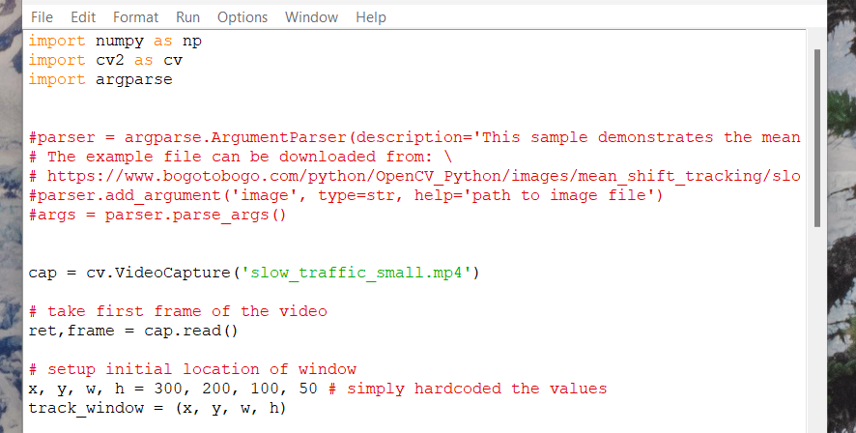

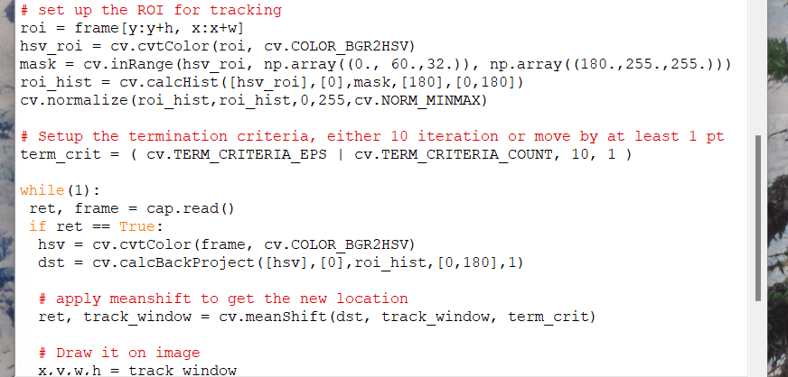

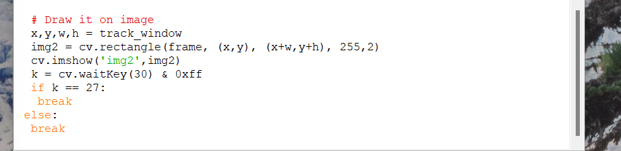

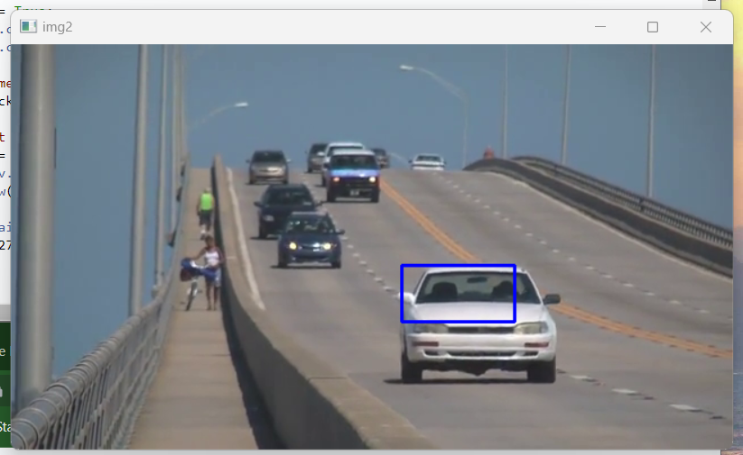

Meanshift results

Window stays same size

CAMshift Continuously Adaptive Meanshift

Applies meanshift first

Once meanshift converges, it updates the size of the window and calculates the orientation of the best fitting ellipse to the points

Process repeats in new search window until desired accuracy is met

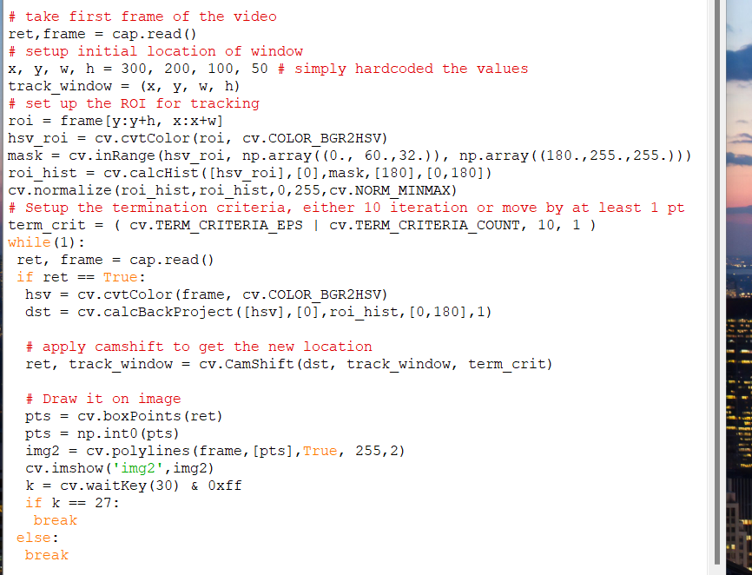

cv.Camshift provides rotation and size change for window

Results

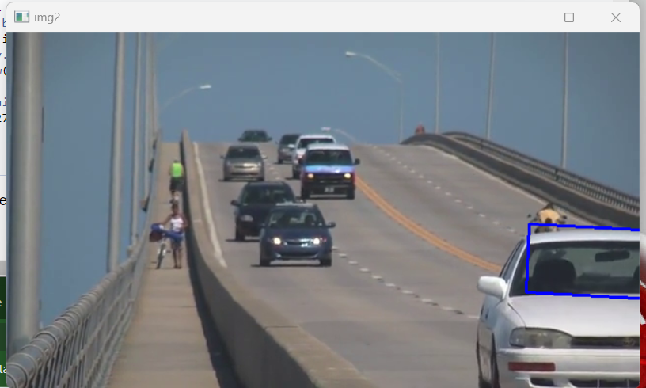

Box rotates at each frame